Breakdown Sheet
Materials/Textures Reel Winter 2009

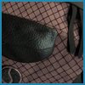 | Procedurally Textured Bag - A texture experiment designed to push the boundaries of procedurally generated textures in a photorealistic sense. Reference was highly utilized to capture the look and feel of different surfaces.  - Autodesk Maya.
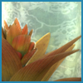 | Flower - An experiment in the application of subsurface scattering and fur in a systematic manner. Full breakdown is included to show the effects of diffused light on the surface as well as the layers of texture.  - Autodesk Maya  - Nuke
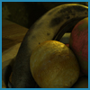 | Vanitas - Based on the Medieval theme of Vanitas. Features all painted and edited textures.  - Adobe Photoshop  - Autodesk Maya
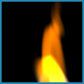 | RenderMan Flame - An experimentation using RenderMan Shading Language. This fire was created by animating noise on the ST Grid and Implementing gradients using specific smoothstep and sine functions. Parameters were created to control the speed, oxygen, size, incandescence and translucency of flame. The flame was then mapped onto 100 grids to create a volumetric look. Noise can be offset and randomized on each grid to add variation. Visit My RenderMan page for more information.  - RSL  - Cutter

